Tuesday 14 March 2023 at 7.00 pm in person at Bearsden Academy

Mr Healy
Stuart Dickson (PC Secretary & Acting Chair of PC for this meeting)
January Morgan White (Chair of PTA)
Debbie Monaghan
Lisa Manchanda
Katherine Sneeden
Andrea Glendinning
Samantha Gorrie
Jacqueline MacLean
Joyce Ling
Lucy Roy
Caroline Miller
Jennifer McMartin
Helen Hollister

- Welcome & Apologies

Stuart noted apologies from Mr Cooper, Chris Dorman, and Rachel Huston. The PTA noted apologies from Shirley Anne and Ashley Kellock.

- Introduction from the chair

Stuart welcomed everyone to the meeting. He explained that Chris had sent his apologies and therefore he would be acting as chair for this meeting. He also explained that we would go through the regular Parent Council business before doing the AGMs of both the PC and the PTA.

- Minutes of previous meeting held on 7th February 2023

The minutes of the previous PC meeting were circulated and approved.

- Matters arising

Stuart said that, with the approval of other members, he had written to the SQA (copying in the Cabinet Secretary for Education and the EDC Head of Education) asking for a blanket

‘Exceptional Circumstances Consideration’ to apply to pupils sitting SQA exams from Bearsden Academy given the number of targeted strike days already seen by pupils in EDC and the number which were set to happen at the time.

Stuart read out a reply from Fiona Robertson, the Chief Executive of the SQA. Essentially, the answer was no and she highlighted that the SQA and local authorities had been sensitive to this issue and allowed flexibility to those affected such as by extending deadlines for coursework. Mr Healy also highlighted that the school was offering an increased amount of supported study, including at weekends and evenings. Some coursework has been cut and the Academy have asked for further extensions where needed.

Lisa discussed vaping. She distributed a leaflet she had seen which she found to be quite educational. Were the school discussing the dangers of vaping with pupils in, for example, in PSE lessons? Mr Healy said that he believed that this kind of education was already happening. He checked with guidance teachers following this meeting and confirmed this to Stuart by email.

- Parent Council AGM

Stuart gave a short presentation about the background to the Parent Council. These were set up in 2006 by the Scottish Government and consist of a subset of parents who represent the views, concerns, and interests of all the parents and guardian of pupils attending the school.

He noted that the theme of the meetings in the past 12 months was ‘a return to normality’. Many of the interesting things which make the school special have come back quickly following the pandemic, including
- after school clubs
- parents’ evenings
- careers’ evenings
- school trips
- the kitchen garden
- the John Muir and Duke of Edinburgh awards
- Homework classes
- Music events

Stuart noted the work of Mr Liddle who has spoken to many members and other parents about the school improvement plan.

He highlighted the number of days study lost to strikes (7 at the time of the meeting) and said there were still lingering worries about the affect this would have on the success of pupils in exams.

Finally, he thanked Mr Cooper, senior management, year heads, the teachers and the support staff who all played big parts in making the school the success it is – long may it continue.

- PTA AGM

January introduced the PTA committee and handed over to Samantha to present.
- Funding generated by the PTA provides additional resources to support our children’s education and supports activities that promote their welfare
- We strive to deliver a welcoming and inclusive ethos by supporting key school events, such as new S1 parent’s evenings, the Christmas fair, the Drama department and Leaver’s activities
- The group and its’ activities enable parents, staff, pupils and the local community to work together creatively, inclusively and in a fun environment – while raising as much money as possible to support the school & pupils
Chairperson: January Morgan White
Treasurer: Samantha Gorrie
Secretary: Jacqueline MacLean
- There are 10 current members, all are Trustees, they are: January Morgan White; Samantha Gorrie; Jacqueline MacLean; Andrea Glendinning; Shirley-Anne Lloyd; Helen Hollister; Vicky McCabe; Ashley Kellock; Joyce Ling; Romali Rosales
- We also have a larger group of circa 30 volunteers willing to help with our events and activities
- As always, we would be delighted to welcome any new faces to the group to support with events, activities and to provide ideas and input.

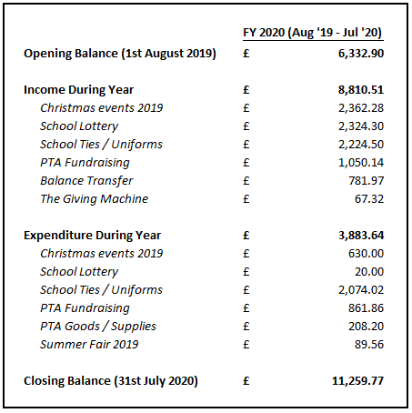
- Key fundraising activities were the Christmas 2019 Fair, Coffee morning and Tea / Coffee stall at the Drama dept. evenings which raised £1,921 (net)
- The School Lottery grew considerably from previous years contributing £2,304 in FY’20 (net)
- The PTA closed an unused a/c to streamline transactions and transferred the balance into the main PTA account
- Sadly very few activities were funded during this period as a result of Covid restrictions. This, coupled with a strong fundraising start to the year, meant we took a closing balance of £11,260 into FY’21

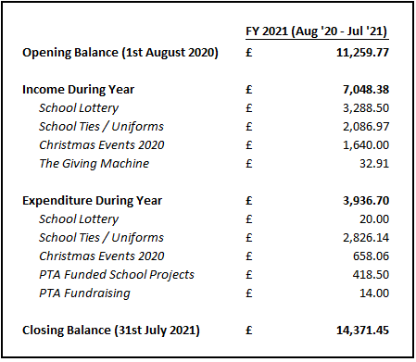
- As face to face events were limited for the majority of the year we relied on the Christmas raffle and the School Lottery for the majority of our income in FY’21, raising £982 and £3,268 respectively (net)
- Unfortunately few activities could be funded during this period due to Covid restrictions however the PTA were able to support an essential mask- making project within the technical department at a cost of £418.
- We closed the year with a balance of £14,370 despite a YoY reduction of £1,762 in fundraising income.

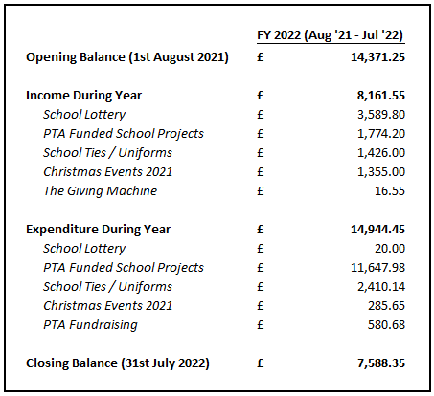
- The School Lottery had a record-breaking year in FY’22 with 120 people participating, this income source generated £3,570 (net) for the PTA funds
- We again held a virtual Christmas raffle, which raised £1,069 (net) and were delighted to again fund Christmas hampers for a number of people in the local community. These were very positively received.
- This year we had multiple requests from funding from the school which we were delighted to support including laptops; audio visual equipment and graphics for the glass meeting room; a barista coffee machine & fridge to support training & development for senior pupils and generate additional income for the school. Our total project funding was £9,874 net.

- We would welcome any new members to the organisation, our meeting will be in late March and we’d love to see some new faces there
- We would also welcome any new ideas for fundraising initiatives, particularly given the unprecedented circumstances we are now working in. Please speak to any member of the PTA with any suggestions / ideas you may have.
- Thank you to all of the PTA members, Bearsden Academy staff, pupil volunteers and parents who have helped us over the past year – we look forward to continuing to work with you.
- Date of Next Meeting

Stuart thanked attendees and closed the meeting. The date for the next PC meeting was agreed as being 6th June 2023 in person in the school.

